**A Report On**

**SUMMER INTERNSHIP-2 (4351901)**

**At**

**BBIT**

**SUBMITTED BY: -**

**NAME OF THE STUDENT:** Patel Dhara Jigneshkumar

**ENROLLMENT No.:** 236040307092

**MENTOR NAME:** Dr. Bharat V. Chawda

**DURATION OF INTERNSHIP:** 27/05/2025 to 8/07/2025 (6 Weeks)

**SUBMITTED TO: -**

DEPARTMENT OF COMPUTER ENGINEERING (GIA)

B & B INSTITUTE OF TECHNOLOGY, VALLBHA VIDHAYNAGAR

2025 – 2026

**ACKNOWLEDGEMENT**

First and foremost, I would like to thank **B & B INSTITUTE OF TECHNOLOGY**forgiving me a golden opportunity to pursue my ***Diploma in Computer Engineering.*** It was a great learning experience of my life.

I would also like to thank ***B & B Institute of technology*** for granting me permission toundergo my internship-2 carried on at v v nagar.I would like to thank ***Dr. Bharat Chawda*** for their continuous support, guidance time, effort in conducting my internship at your Company.

Mainly I would like to thank **Dr. Bharat Chawda V. “Lecturer”**, for providing continuous guideline and support during the whole internship and preparing this report. Without his/ her support thisreport would not have seen a light of the day.

Last but not least I would like to acknowledge all those who are directly or indirectly

involved in the Internship.

**DECLARATION**

Here I am **Patel Dhara Jigneshkumar** the student of B & B Institute of Technology, Vallabh Vidyanagar from the Department of **Computer Engineering**. of the academic year 2023‐2024 declared that have completed this internship-2 (4351901) in **BBIT** in my current 5th Semester. The Information submitted in this report is true and original to the best of my knowledge. This report has not been submitted at any other place or university before submitting here.

Name : Patel Dhara Jigneshkumar

Enrolment No:- 236040307092

PLACE:- V V Nagar

DATE:-

**SCANNED COPY OF INTERNSHIP CERTIFICATE SHOULD BE IN THIS PAGE**

**Evaluation Rubrics for Industry**

**Enrolment No: 236040307092 Branch: Computer GIA**

**Name of the Student: Patel Dhara J.**

**Date of Evaluation: ______________________**

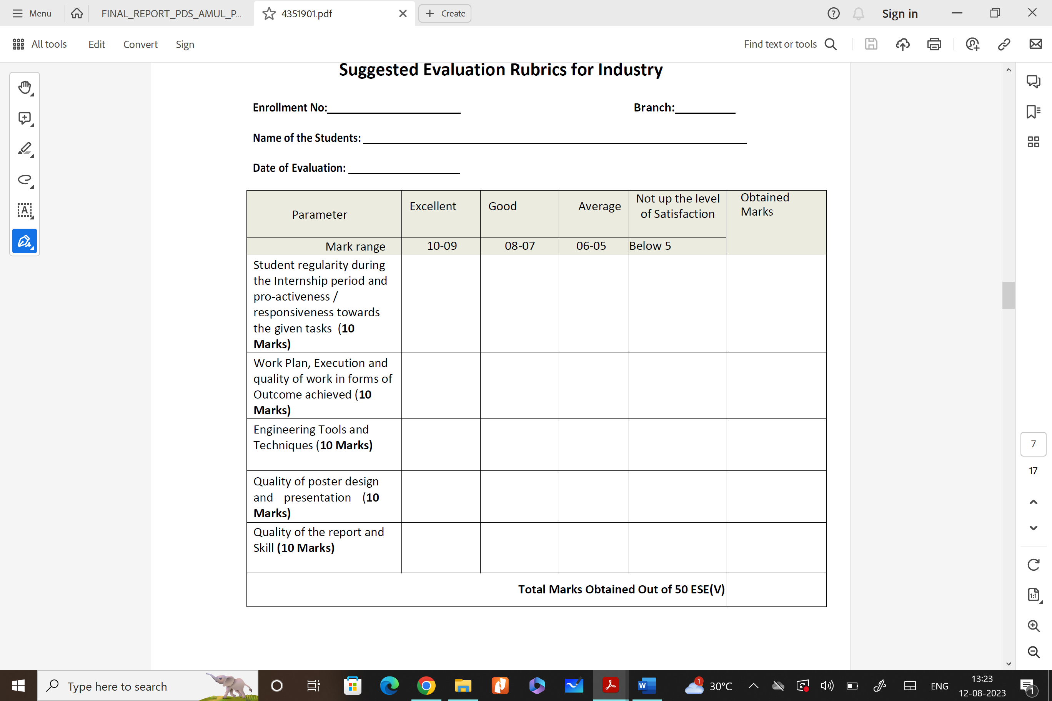

E**xternal Examiner Name:**

**Signature:**

**Evaluation Rubrics for Institute**

**Enrolment No: 236040307092 Branch: Computer GIA**

**Name of the Student: Patel Dhara J.**

**Date of Evaluation: ______________________**

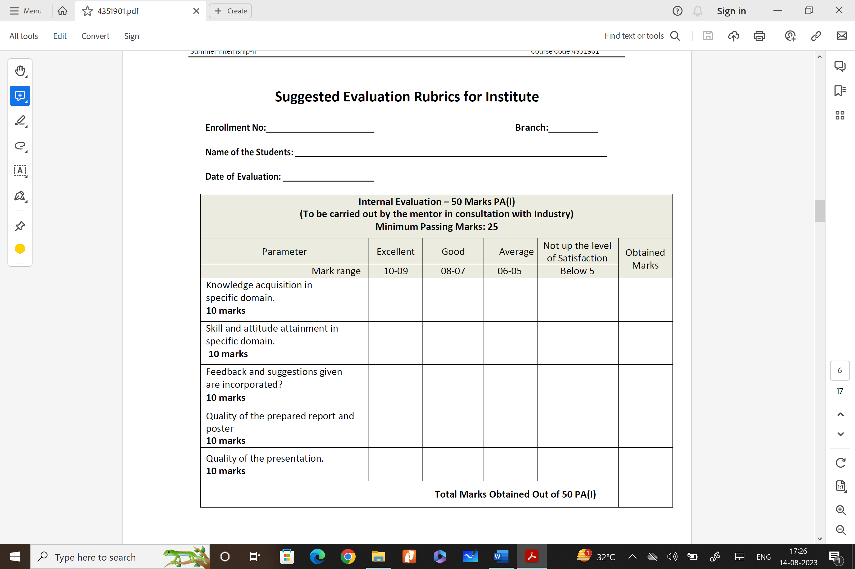

**Internal Examiner Name : Dr. Bharat V. Chawda**

**Signature:**

**TABLE OF CONTENT**

|  |  |  |
| --- | --- | --- |
| **Sr No.** | **TOPICS** | **PAGE NO** |
| 1. | Introduction |  |
| 2. | Company Profile |  |
| 3 | Daily Diary |  |
| 4. | System Analysis and Requirements |  |
| 5. | Database Creation for system |  |
|  |  |  |
|  | Internship Poster |  |
|  | References |  |

**CHAPTER - 01**

**INTRODUCTION**

**About the Internship**

This mini project was carried out as part of my academic internship requirements. Unlike a company-based internship, this project was done individually but with proper guidance and planning. The goal was to practically apply the concepts I’ve studied in my course and to experience how a small software development process actually works. Although it was a self-project, it was developed under the mentorship of **Dr. Bharat V. Chawda**, who provided valuable suggestions and support throughout the development period.

This self-driven project helped in understanding how to break down a task, research the required technologies, plan a workflow, and implement it step by step. It also provided a great opportunity to improve technical skills and gain confidence in solving problems practically.

**Project Introduction**

The project focuses on **developing a simple real-time chat application using PHP**. In today's world, real-time communication has become an important part of many websites and platforms. Whether it's messaging between users, live support, or notifications—these features help in keeping users connected and engaged.

This project demonstrates the basic working of such communication by allowing users to exchange messages without refreshing the page. The system is designed in a way that one user can send a message, and the other user can see it immediately. It also includes features like storing messages, displaying them in order, and keeping the user interface simple and easy to understand.

Through this, I was able to explore how real-time messaging systems are structured using basic web technologies like HTML, CSS, JavaScript (for dynamic updates), and PHP (for handling the server-side logic).

**Objective and Outcome**

The main goal of this project was to **learn how real-time communication works** on websites and to **build a chat application** independently from scratch. The idea was not just to study it in theory but to actually apply those concepts by creating a working system.

Through this mini project, I was able to:

* Apply the theoretical knowledge gained in class to a real-world problem.
* Understand how users can send and receive messages without page reload.
* Improve my coding skills, especially in front-end and back-end integration.
* Learn how to plan and work through a complete project lifecycle.
* Solve real-time development issues and debug errors independently.
* **Implement the full software engineering process** including planning, design, development, testing, and documentation, as learned in previous semesters.
* **Strengthen the link between academic study and practical application**, which also improved my subject understanding.

By the end of the project, I felt more confident in handling practical tasks and solving problems independently using the tools and knowledge I’ve studied in my course.

**Importance of Internship / Project Work**

Doing this project played an important role in my learning. It allowed me to:

* Work on a task and take full responsibility.
* Follow professional behavior like time management and organized coding.
* Understand how projects are developed step-by-step, from idea to implementation.
* Prepare for future industry requirements by gaining hands-on experience.
* Explore my interest in web development and real-time systems.

Such projects help students like me connect what we learn in class to how it is actually used. It improves both technical knowledge and the ability to think and work independently.

**Internship Organization**

This mini project was done as a **self-project**, but it was carried out under the guidance of **Dr. Bharat V. Chawda**, who provided proper support and mentorship throughout the internship period. He is associated with our institute and helped me by giving valuable suggestions and reviewing my progress.

Even though it was not done in an outside company, the experience felt similar to a real-world setup, as I had to plan, build, and test the system within a limited time while reporting updates to my mentor.

**CHAPTER -02**

**COMPANY PROFILE**

In this Chapter student must right about company profile, what they manufacture, types of Machines, processes, Quality control, Various Certificates of the company etc.

Students can take the data from the company itself or from the Company Website.

In this chapter following data should be there:

Name of the industry:

Address of Industry:

Duration of internship:

Name of Student:

Industry Profile:

Product details and production capacity:

Turnover of the Industry:

Client’s details (if available):

Machinery &Equipment details with major specifications:

Raw material details with consumables:

Processes carried out with parameters and detailed description:

Various Departments and its functions:

Knowledge / skill achieved during internship:

Miscellaneous if any:

**CHAPTER – 04**

**System Analysis and Requirements**

This chapter focuses on the detailed analysis of the chat system project. It covers the collection of requirements, both functional and non-functional, and outlines the scope and problem definition to ensure a comprehensive understanding of the system's development goals.

**Requirement Collection**

To develop an effective and user-friendly chat application, we conducted requirement collection from various sources such as observation of existing platforms, user expectations, and technical feasibility. The following requirements were identified:

* **User Registration:** A user must be able to register with a unique username, email, and password.
* **User Login:** Only registered users should be able to log in to the system using their credentials.
* **Real-Time Messaging:** Users should be able to send and receive messages instantly.
* **Recent Chat List:** A list of recently communicated users should appear on the sidebar for easy access.
* **Message Management:** Users should be able to edit or delete their own messages.
* **User Search:** A search functionality must allow users to find other users and start a chat.
* **Message Alerts:** New incoming messages should trigger alerts.
* **Chat Interface:** Should resemble popular messaging platforms like WhatsApp, with user panel and chat panel.
* **Timestamp and Date Display:** Messages must show time, and the date should appear only when the day changes.

**Functional Requirements**

**These are the core functionalities the system must provide:**

1. **User Authentication**
   * Register new users
   * Secure login with session management
2. **Message Exchange**
   * Send, receive, and view messages
   * Append messages in real-time
3. **User Interface**
   * Responsive and modern chat UI
   * Search bar for finding users
4. **Sidebar Management**
   * Show recently contacted users
   * Click to open specific chat
5. **Message Operations**
   * Edit and delete own messages
   * Display message time and group by date

**Non-Functional Requirements**

1. **Performance**
   * Messages must load within 2 seconds
   * Scroll should auto-adjust on new messages
2. **Usability**
   * Intuitive layout
   * Easy navigation with icons and styling
3. **Security**
   * Passwords stored using hashing
   * Session management for logged-in users
4. **Reliability**
   * Messages should not be lost even after refresh
   * Proper error handling in message sending
5. **Maintainability**
   * Modular code structure for easy updates
   * Separation of backend and frontend logic

**Scope of the Project**

**The chat system was designed with the following scope in mind:**

* To support real-time one-to-one messaging
* To manage user sessions securely
* To keep track of recent conversations
* To provide message operations like delete and edit
* To function smoothly across devices with a responsive layout
* To serve as a base system for future extensions like group chat, file sharing, or emoji support

**Conclusion:**

This chapter provides a thorough understanding of the requirements and system analysis, forming the basis for the design and development of the chat application. It ensures the system is aligned with user needs and technical feasibility, setting a strong foundation for implementation.

**CHAPTER - 05**

**Database Creation for System**

This chapter describes the design and implementation of the database developed for the system. It explains how the database was structured to ensure efficient data storage, access, and management. The chapter begins by outlining the tools and technologies used, such as MySQL and XAMPP. It then covers the process of identifying key entities and their relationships, leading to the creation of an Entity-Relationship (ER) diagram. The chapter further presents detailed table structures, including attributes, data types, primary and foreign keys, and how the tables are logically connected. Overall, this chapter provides a clear understanding of the database architecture that supports the smooth functioning of the entire system.

**The points are to be covered**

1. **Database Design**

- Defining System Modules

- Defined Entities

- Defining Attribute for each Entities (Entity sets)

- Association among Entities

- Relationship sets and their mapping cardinalities

- ER Diagram (Entity Relationship Diagram)

**2. Database Implementation**

- Queries for each Table

**1. Database Design**

**Defining System Modules**

The database of the Real-Time Chatting System is structured around key modules that represent different core functionalities of the application. Each module is responsible for handling a specific part of the system’s operations such as user management, messaging, blocking users, and typing indicators. These modules are directly reflected in the design of the database tables. Below is a detailed explanation of each module along with the related database structure.

**AT THE END OF REPORT EVERY STUDENT HAS TO MAKE A POSTER OF THE INTERNSHIP AND PUT HERE.**

**Size of Poster**: A3 size (Paper page is allowed/ No Flex Banner)

The poster must contain following details:

1. Title
2. College name & logo
3. GTU logo
4. Industry Name & Logo
5. Students name with Enrolment Number
6. Mentor details both industry & Institute.
7. Details of the internship
8. Outcome of the Internship